INTRODUCTION
A lot of your organization’s time, effort and money go into ensuring that payroll is complaint through a statutory audit. From an employee’s fair treatment of labour to protecting the company from unreasonable wage or benefit demands from trade unions or aggressive employees, every company faces a worrying number of potential legal issues relating to compliance. However, it may never be a company's intent to break these laws, but without necessary protection, it may easily slip through the cracks.
So how can you be sure that you can avoid the risk of non-compliance?
To address this, let's first understand what statutory compliance is and the various compliances required for Indian payroll.
- What is Statutory Compliance?
The word statutory means “of or related to statues”- rules and regulations. Compliance means adherence. Thus, Statutory Compliance means adhering to rules and regulations.
Statutory Compliance in HR refers to the legal framework that an organization should adhere to in dealing with its employees.
- Why is it important?
Every country has its own set of state and central labour laws that companies need to comply with. Dealing with statutory compliance requires companies to be updated on all the labour regulations in their country. It is also mandatory for companies to adhere to them. Non-compliance with these regulations can cause a company a lot of legal trouble such as penalties and fines. That is why every company invests a huge amount of money, effort and time to meet compliance requirements from professional tax to minimum wages act. To help in this, the company seeks expert advice from labour law and taxation law experts.
In order to manage with a demanding regulatory environment, every company should be well versed and take notice of all regulations in the labour laws. They need to formulate efficient ways to maintain compliance and minimize risks.
- Need for Statutory Compliance.
The complexity of doing business has increased tremendously and it has become very challenging to be in sync with the operational aspect of every business. As discussed earlier, an organization seek the help of statutory compliance experts whose focus is to be compliant with the ever-changing regulatory environment.
Also, a lot of companies also provide services on statutory compliance management and have a deeper understanding of the regulatory setting and provide specialized services to organizations. They streamline the process right from the day to day maintenance of prescribed forms and registers to the filing along with reports.
- Is it different for organization?
Statutory compliance for a partnership firm, private limited company, LLP, or any type of company does not change. Every organization that hires employees and pays salaries must comply with the labour laws.

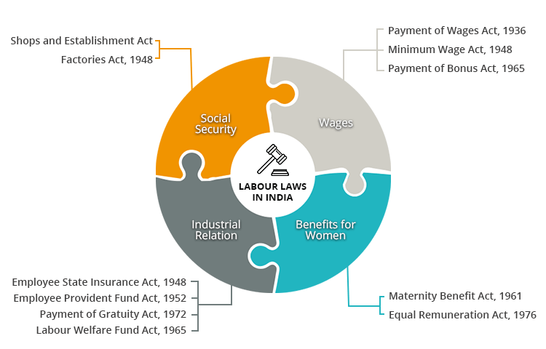

THE ADVANTAGE OF STATUTORY COMPLIANCE FOR EMPLOYEES


Ensures fair treatment of employees

Ensure they are paid fairly for the work they have done and their company complies with the minimum wage rate

Prevents employees from working for long hours or inhuman condition

THE ADVANTAGE OF STATUTORY COMPLIANCE TO ORGANIZATIONS


Avoid penalty or fines because of their timely payments

Protects the organization from unreasonable wage or benefit demands from trade unions

Prevents legal troubles as the company is fully compliant


Mitigate risks and increases awareness about compliance

With compliance in place, there is a lower risk of an adverse incident

IF A COMPANY DOES NOT CONFORM TO RULES AND REGULATIONS IT WILL RISK:


Penal actions and financial losses to the organization

Loss of reputation and business integrity

Customer loyalty will be impacted severely

